St. Mary of the Assumption

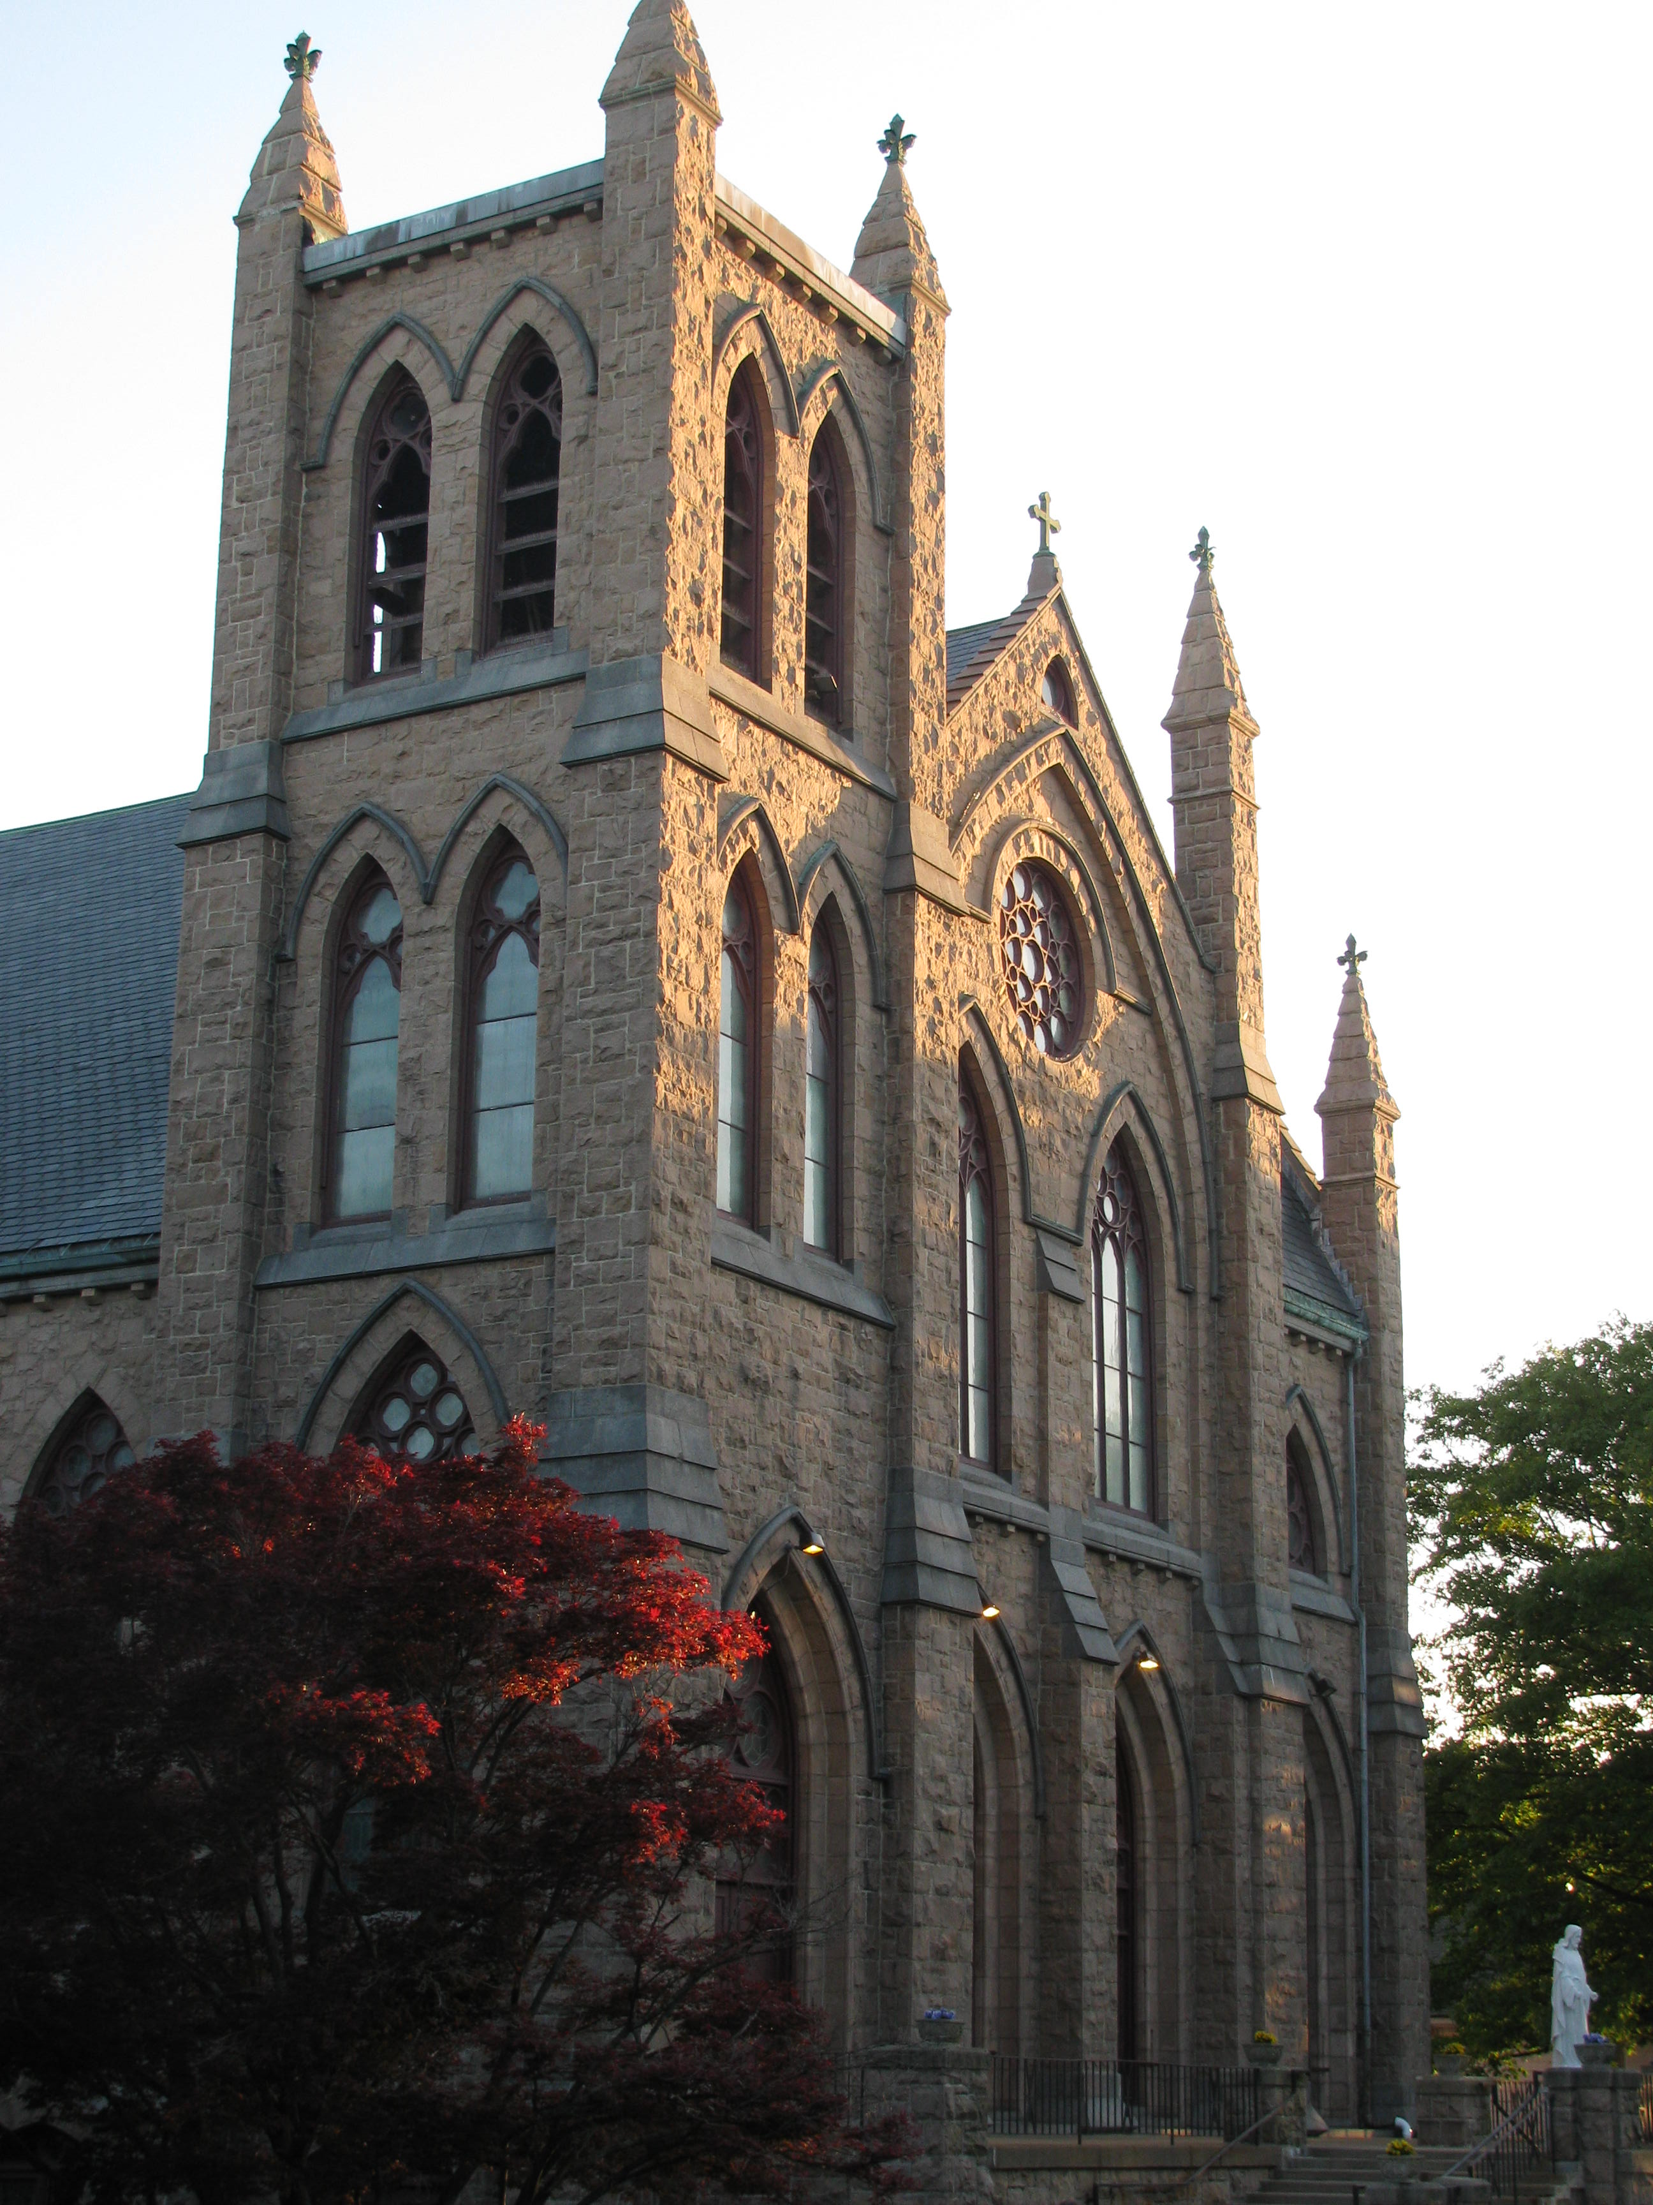

2016 ~ 2017 Annual Parish Report

Fr. Wayne L. Belschner, Pastor

Fr. Mark Storey, Parochial Vicar

Dear Brothers and Sisters in Christ,

It has been almost a year ago since I was assigned to St. Mary of the Assumption Parish. Over this time, I have seen growth both in the parish family and in myself. I sincerely pray that God will continue to bless each and every one of us in the months and years that are ahead with even more growth.

It is no secret that St. Mary’s is a vibrant and wonderful parish. I am blessed to be a part of this extraordinary family. As your pastor, my goal is to assist you in answering that call to holiness. In other words, I am here to play a part in you becoming a saint. This is an awesome responsibility and I am humbled that God has called me to be His instrument, as unworthy as I may be, in this endeavor.

Today, I present to you this *Annual Parish Report* which provides a summary of all that has occurred in this parish over the past year. I am pleased to offer this report not only because it speaks to our accomplishments, but also it clearly demonstrates who we are. In moving forward, I hope that we can build on the foundation and sacrifices of the past. Also, you will find in this report a projection for next year’s budget. Although there is a large posted deficit, I am confident that we will be able to bring it down through fundraising and other activities.

God has blessed us for over 150 years. May what we do together lay a foundation for the next 150 years! Be assured of my prayers for you and kindly remember the staff and me in your prayers. With warmest best wishes, I remain

Sincerely Yours In Christ,

Fr. Wayne

(Rev.) Wayne L. Belschner

Pastor

St. Mary of the Assumption

A Parish History

The history of St. Mary's Parish goes back much farther than 1866. Town history records the presence in 1758 of 11 Catholics - "Acadians" - who were allowed harbor in town as "French Neutrals." They were indeed homeless, because Acadia, or Nova Scotia, had become a British Colony and many Frenchmen had been deported by the British because of grave doubts regarding their loyalty to King George II. There was no Catholic Church in Dedham where these Acadians could worship, and no priest to offer them solace, but the town recognized their religion and gave them refuge.

### The First Mass in Dedham

In the years that followed, Catholics were few in Dedham. Indeed, prior to 1843, the few Catholics in our town walked sixteen miles - eight miles to Roxbury and eight miles back - in order to attend Mass. The first Mass in town was celebrated in 1843 by Father James Strain in Daniel Slattery's home. There were eight Catholics present. Every Sunday, for three years, Daniel Slattery would send his young brother-inlaw, John Dagget, a boy of seventeen, to drive Father Strain from Waltham to Dedham and back. Daniel Slattery's house was subsequently removed and Memorial Hall was erected on the site:

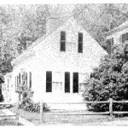

### Early Growth

In 1846, Dedham became part of the Mission of St. Joseph's in Roxbury, and Father Patrick O'Beirne came to Dedham regularly to celebrate Mass on Sunday. There was no church, and Father O'Beirne used Temperance Hall for eleven years. It was in this same Hall that the disturbing issues before the nation were dramatized by a tall, modest speaker whose name was not yet famous - Abraham Lincoln. At this period many Irish were fleeing years of agricultural famine in their beloved Isle, and were emigrating to the United States. Substantial numbers settled in and around Dedham.

### The First Church

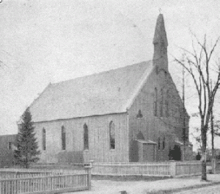

This increasing Catholic population enabled Father O'Beirne to build the first St. Mary's Church in Dedham in 1857. Every Sunday Father O'Beirne said Mass, and during the week he would come to Dedham to meet the needs of his congregation. But the issues of which Abraham Lincoln had spoken in Temperance Hall were now tearing the nation apart. The Civil War was making its effects felt in Dedham. The able-bodied men of St. Mary's readily answered the nation's call. "No church in Dedham lost so many men in proportion to their numbers," says the Dedham Transcript in its edition celebrating the 325th Anniversary of our town. And so the "newcomers" of the past two decades from Ireland became indeed a part of Dedham. Now their patriotism was proved, for it was written in blood. And now at last their Catholic religion came to be regarded with a degree of tolerance not known before.

### ****The First Rectory of St. Mary's****

In 1867 Father Brennan purchased a plot of land with a house on High Street, converting the home into a Rectory. It soon became evident to Father Brennan that he would need a new Church, for Catholics were still arriving in great numbers from Ireland. Soon his duties became so arduous that he was given an assistant Pastor, the Rev. John D. Tierney. Today it is worthy of note that Father Tierney was unsalaried, though he had the distinction of being St. Mary's first Curate. A year later he was appointed Rector of the Church of the Holy Family, Rockland. As time went on, Father Brennan found his duties becoming more and more demanding. He was also responsible for the Mission in Norwood, which required much attention. It is said that in the attempt to save time he would often send the church collections, uncounted, to the bank. He hoped, of course, that the bank would count the money and credit him with the total. After eleven years of faithful service, Father Brennan resigned in 1877, to be succeeded by Father Denis J. Donovan, who had been assistant Pastor for a year. Father Donovan baptized one of the sons of the Parish who was to become a Prelate of the Church, Monsignor Charles A. Finn.

### ****The Cornerstone of St. Mary's Church****

In October 1880, in the face of financial difficulties, with unswerving faith, Father Johnson invited Archbishop John J. Williams to lay the cornerstone of our present Church. Priests from all the neighboring parishes attended the ceremony. A special train was run from Boston, bringing a large number of friends and a choir of 100 singers. Thousands witnessed the ceremony. Nearly all the local officials of Dedham and business men attended - this universal recognition from the town being a great tribute to the warmth and friendliness of Father Johnson. As many of these officials knew, the Master of Ceremonies, Rev. Theodore A. Metcalf, was a descendant of Michael Metcalf, one of the original settlers who founded the "plantation" of Dedham in 1635. In this well attended ceremony there was also proof that Dedham had never adapted the harsh and narrow measures instituted in Boston and Charleston against those of different religious views. It was in 1880 also, at a Town meeting, that Dedham officials recognized the increasing number of Catholics by reserving a part of Brookdale Cemetery for deceased members of our Faith. During his pastorate, Father Johnson made grateful use of this offer.

### ****The Basement Church****

The building of the Church exterior proceeded rapidly, though lack of funds slowed the furnishing and decoration of the whole interior. Father Johnson had decided to erect a "Cathedral" but cathedrals cost money, and take time for their completion. So the basement was finished first, then furnished, and handsomely decorated. In the meantime the old church had been destroyed, and it was necessary to say Mass in the basement. Indeed, for many years the basement proved to be a serviceable church. The Main Altar, large and substantial, was constructed of marble. The two smaller altars were of wood, delicately carved, and the statues were works of art. The need for money became greater than ever. It was at this time, in 1881, that Mr. A. W. Nickerson, a Protestant whose generosity had endeared him to St. Mary's, paid off the standing debt of the old church and contributed $10,000.00 toward the erection of the new church. Another Protestant, Mr. John R. Bullard, donated the Dedham granite of which the church is constructed. In the "History of the Aschdiocese of Boston," (1895), it is written that "The benevolence of these two Protestant gentlemen is worthy of note, and the local Catholics hope their names may long live in the memory of the future parishioners of St. Mary's . . For financial reasons, when the exterior of the Upper Church was completed, its interior was left unfurnished, though it was used on rare occasions for Fairs and various other important gatherings.

### ****The Dedication of St. Mary's Church****

On September 9, 1900, St. Mary's Church was dedicated by Archbishop Williams of Boston. In his dedication sermon Archbishop Williams said:

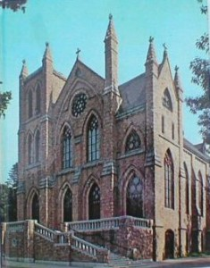

"Today, my beloved brethren, like unto Solomon on the occasion of the dedication of the Great Temple of Jerusalem, your zealous Pastor proclaims that you have built a house in God's name . . . To you has been reserved the privilege of offering to God a house as worthy of His Name as this beautiful structure in which we are assembled this morning."

Father Fleming also purchased land for a Cemetery in West Roxbury, preferring that Catholics be buried in a lot of their own. For up to this time Catholics had been buried in Brookdale Cemetery, in that portion of the ground which had been reserved in 1880 for deceased Catholics.

### St. Mary's Today

The parish maintained the majority of its properties throughout the later half of the 20th century. With the emergence of the Life Teen program in 1997, the basement of the school building was converted into a central gathering place. In 2010, the school building was razed and the lot developed into a needed parking lot. This allowed for a complete renovation of the Lower Church, dividing the area into two spaces: Mary Hall and the Life House for the Life Teen program.

**St. Mary of the Assumption**

**Mass Schedule**

Saturday 4:00pm

Sunday 7:00am, 9:00am, 11:00am, &

5:00pm ~ LifeTeen Liturgy

Weekdays (Monday - Friday) 7:00am & 12:10 p.m.

Tuesday evenings at 7:00pm

Saturdays 8:00am

*************************************************

**Confession Schedule**

Tuesday 3:00 - 4:00pm (Chapel)

Friday 3:00 - 4:00pm (Chapel)

Friday 6:00 - 7:00pm (Church)

Saturday 2:30 - 4:00pm (Church)

*************************************************

**Online Giving**

Now is a great time to sign up for “ParishPay,” our online giving program! Please consider signing up for online giving so that we can continue to meet our financial needs; especially, during vacation time and summer months. “ParishPay” is very user-friendly, and donating is simple, safe, and secure. With “ParishPay” you can set up a recurring transaction using your checking, savings, or credit card account. Plus, you can decide how much to give to any collection and make changes any time of day or night. If you would like to enroll in Online Giving:

1. Visit **www.stmarysdedham.com**.

2. Go to the “Financial Support” tab, and

3. Click on the “Online Giving” button

4. Then follow the directions.

Thank You!

*************************************************

*Please take an opportunity to visit the new and updated parish website where you will see such items as the Minutes from the recent Parish Pastoral Council and the Parish Finance Council meetings. Also, the website contains upcoming events hosted by the parish and other information relating to our life of faith together.*

**www.stmarysdedham.com**

**A Sacramental Journey**

|  |  |
| --- | --- |
| Baptisms | 96 children and 2 adults were baptized |
| First Holy Communions | 46 children and 5 adults received their First Holy Communion |
| Confirmations | 65 men and women confirmed |
| Holy Matrimony | 17 couples married |
| Funerals | 114 Funeral Masses and services |

**A Pastoral Care Glance at St. Mary’s Ministries**

|  |  |
| --- | --- |
| *Adult Altar Servers for Funerals*  *Adult Choir*  *Adult Faith Formation*  *Bereavement Services*  *Bible Studies*  *Book Club*  *Charismatic Prayer Group*  *Christmas Giving Tree*  *Children’s Choir (New Ministry)*  *EDGE Middle School Religious Education*  *Eucharistic Adoration*  *Exercise Classes for Seniors*  *Extraordinary Ministers of the Eucharist*  *Homebound Care*  *Finance Council*  *First Saturday Devotions*  *Greeters at Mass*  *Kiss of Mercy Ministry*  *Knights of Columbus Dedham Council*  *Lectors*  *Legion of Mary* | *Life Teen (20th Anniversary)*  *Mother’s Club*  *New Parishioners Welcoming (New Ministry)*  *Parish Council*  *Prayer Ministry ~ John 10:10*  *Pro-Life Activities*  *Rosary Walking Groups*  *RCIA ~ Adult Sacramental Program*  *Religious Education (Grades K-5)*  *ROC ~ High School Confirmation Program*  *St. Martha’s Guild*  *Seniors Luncheon*  *Social Committee*  *Social Justice Committee*  *Special Education for Religious Education*  *St. Mary’s Prayer Line*  *Rosary Groups*  *Saint Vincent de Paul Society*  *Sunday Offertory Collection Counters*  *Ushers for Masses*  *Youth Altar Servers* |

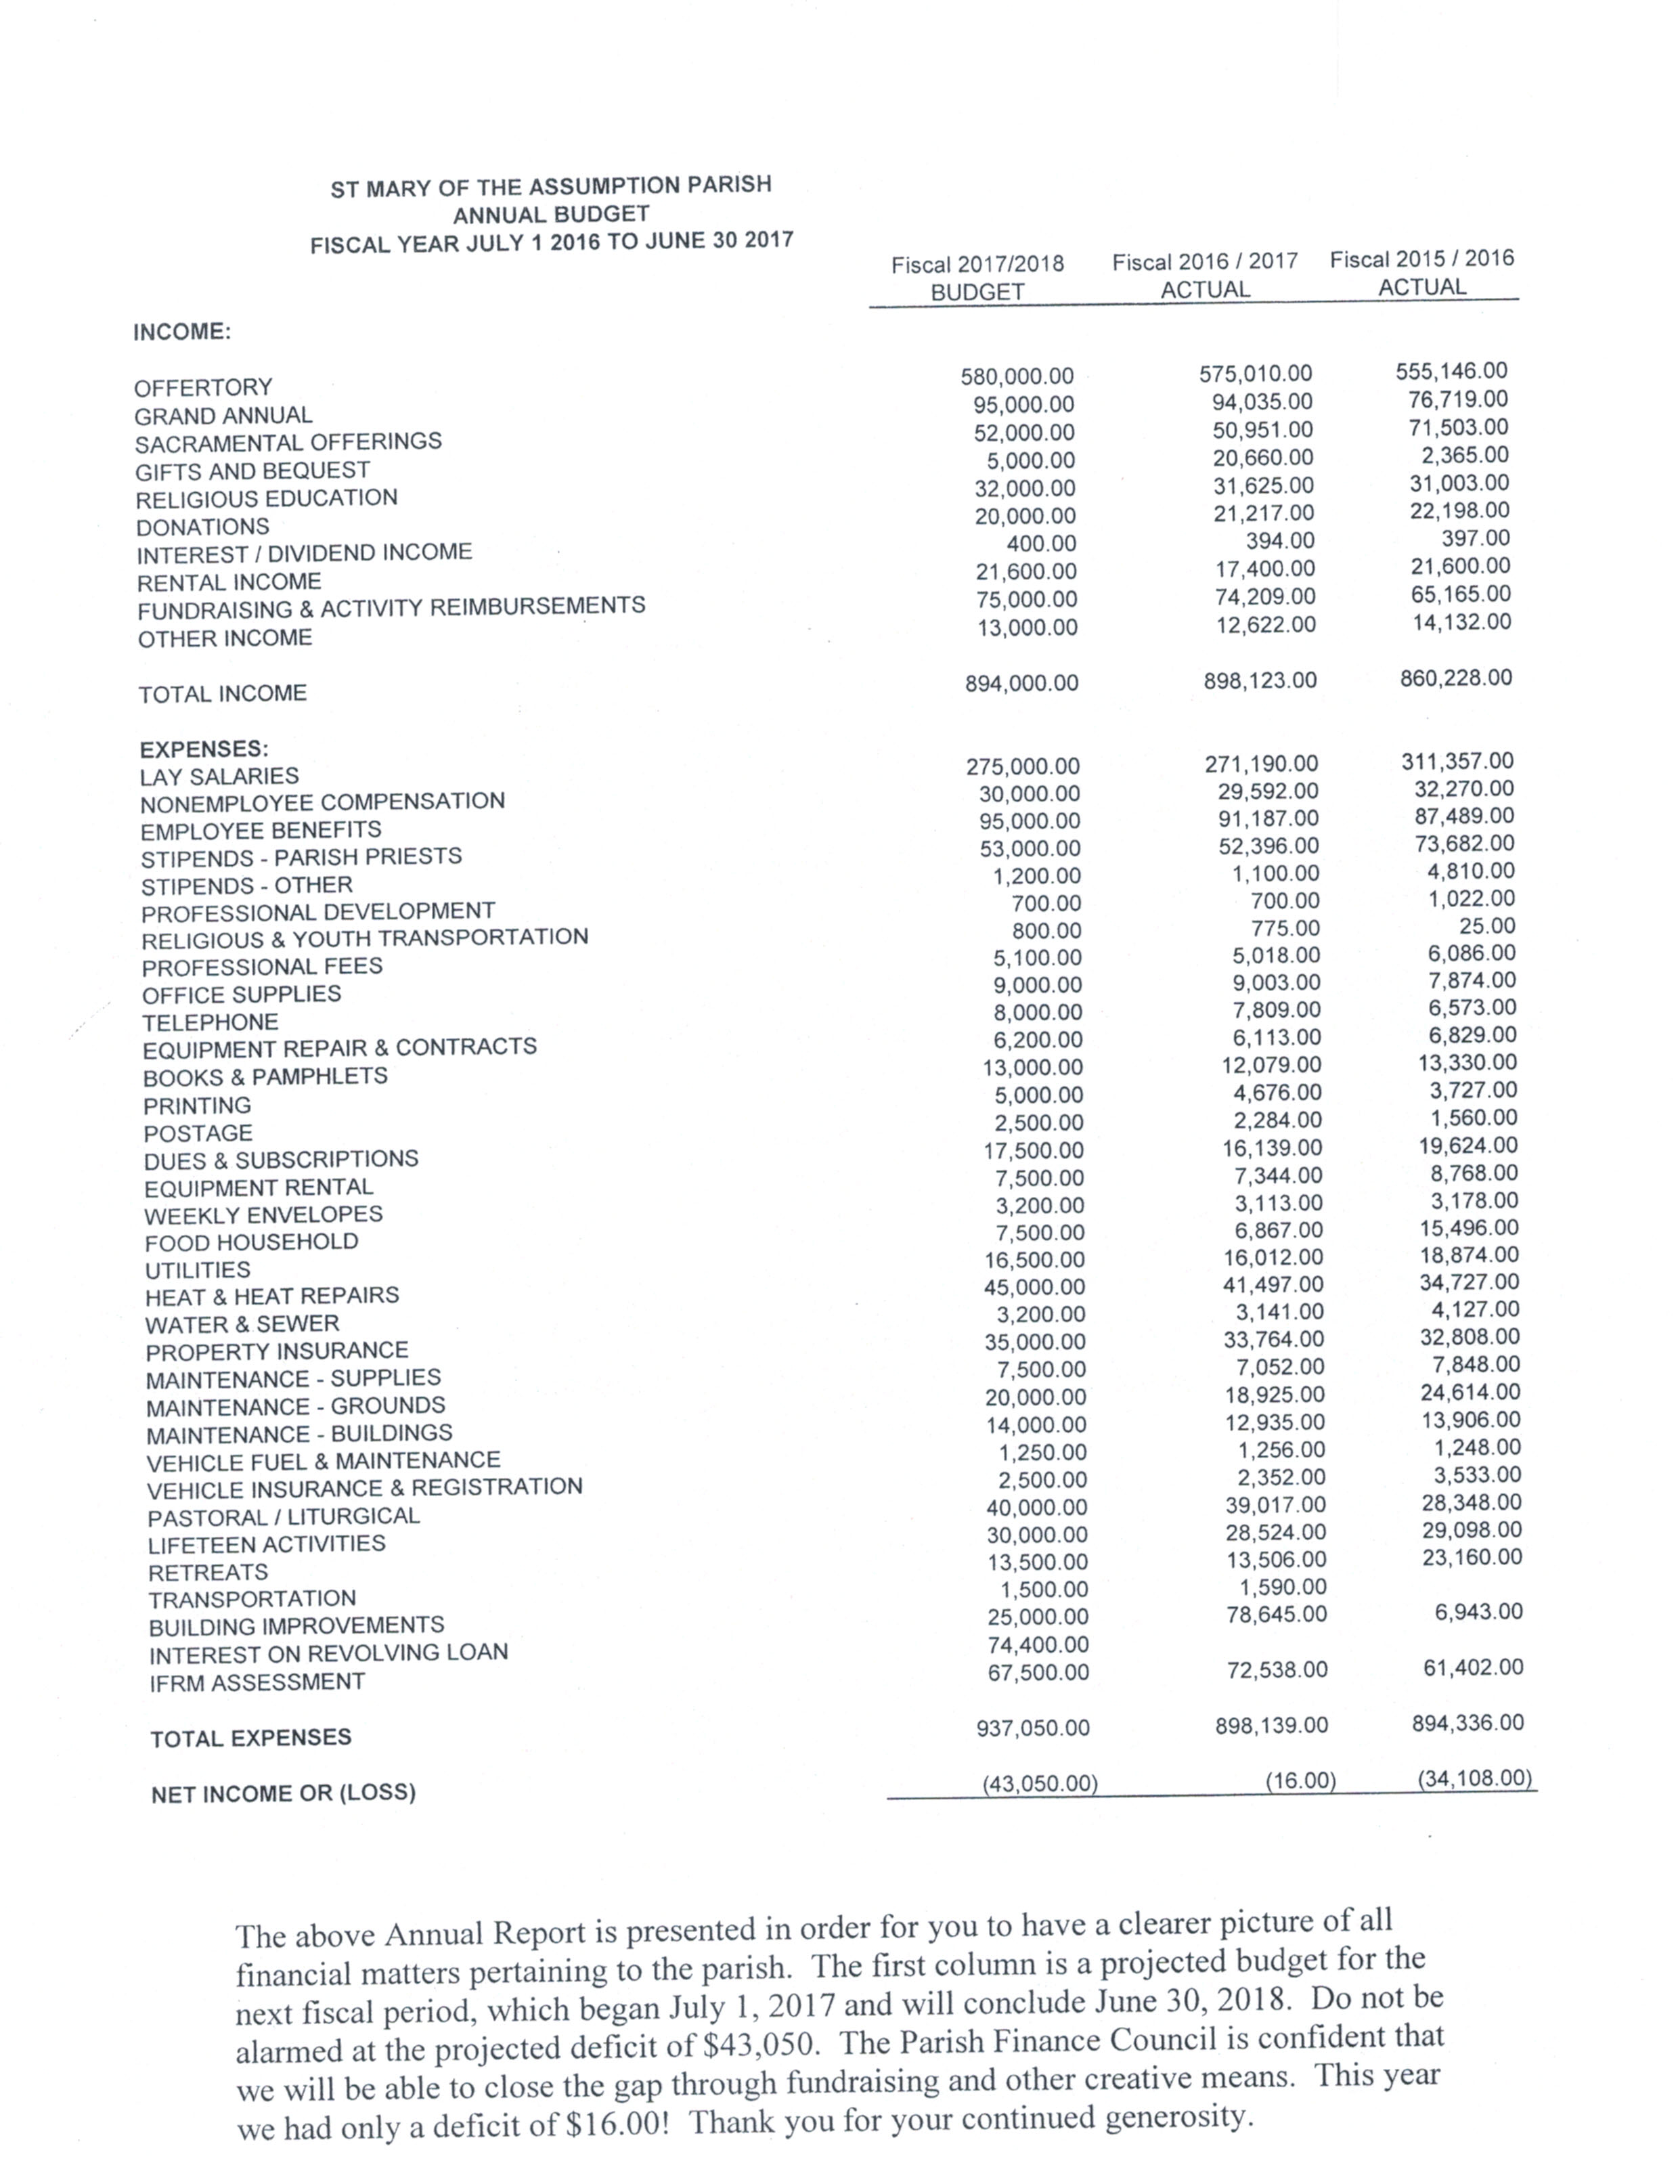

**Your Parish Finance Council**

### Current Members:

**Fr. Wayne L. Belschner, Pastor**

**Fr. Mark Storey, Parochial Vicar**

**Steve Burbank, Chair**

**Bonnie Featherstone**

**William Flanagan**

**Stephen Gentile, Vice Chair**

**Rich Killgoar**

**Mike Lembo**

**Tom Polito**

Once again, we would like to inform you that all Parish Finance Council Minutes and Budgets are posted online. The Parish Finance Council Minutes are located in the “About Us” tab under the section marked “Finance Council.” All budgets for the parish are located in the “Financial Support” tab. Please know that we take seriously the stewardship of your donations and are committed to financial transparency.

Through the generosity of our parishioners, we were able to undertake several important projects this past fiscal year; as well as, make payments to the parish debt.

The Parish Debt stands at $839,569.00. Since September, we have paid down the debt $57,132.This year, we will begin once again paying interest on the debt. Last year was an interest free year, which allowed us to pay directly on the principle.

Several projects that were begun and completed this past fiscal year included: complete restoration of the Church’s Bell Tower, repairs to the roof of the Parish Center, the replacement of over 111 slate tiles on the Church roof, and repairs and repainting of the rectory main entrance.

